**Dia Aberto na Sede do GDC: Atividades Desportivas e Terapias Complementares**

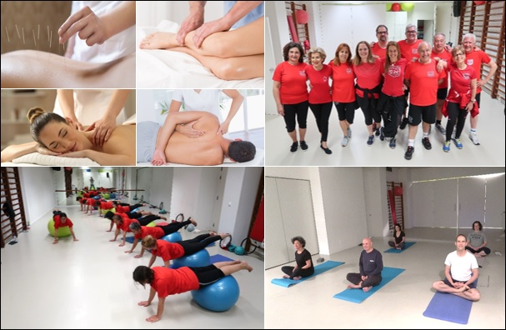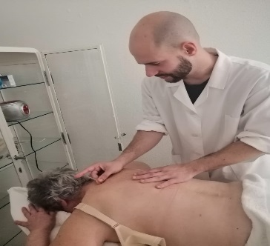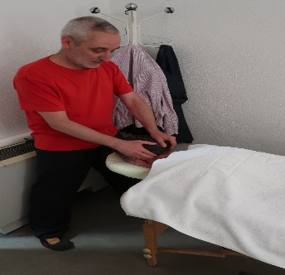

No dia **28 de setembro** (sábado)o GDC organiza o **Dia Aberto** que pretende dar a oportunidade aos associados de participarem, gratuitamente, em aulas de **ginástica**, **pilates** e **yoga**, na Sede. Para além, das atividades desportivas ainda poderão experimentar as seguintes terapias complementares: **massagens Tui Na,** **massagens com pedras quentes**, **drenagem linfática manual** e **acupuntura**.

A inscrição deverá ser enviada para [grupo.desportivo.reservas@fidelidade.pt](mailto:grupo.desportivo.reservas@fidelidade.pt) até **26/09/19.**

**Deverá trazer tapete de yoga/pilates.**

|  |  |
| --- | --- |
| **Terapias Complementares** | |
| **Massagem Tui Na, Pedras Quentes**  **e Drenagem Linfática** | **Acupuntura e Massagem Tui Na** |
| **9h30 - 13h30** | **9h30 - 13h30** |
| **João Santos** | **Miguel Gomes** |

|  |  |  |
| --- | --- | --- |
| **Atividades Desportivas** | | |
| **Ginástica** | **Pilates** | **Yoga** |
| **9h45** | **10h45** | **11h45** |
| **Sandra Neto** | **Elsa Alvelos** | **Filipe Ângelo**  **e Carita Mechas** |

**Nota: Poderá participar em todas as aulas. No caso das terapias complementares as sessões são de 15 minutos cada, estando limitadas a um máximo de 16 sessões por tipo de terapia.**

|  |  |  |  |  |  |  |  |  |  |  |  |  |  |  |  |  |  |  |  |  |  |  |  |  |  |  |  |  |  |  |  |  |  |  |  |  |  |  |  |  |  |  |  |  |  |  |  |  |  |  |  |  |  |  |  |  |  |  |  |  |  |  |  |  |  |  |  |  |  |  |  |  |  |  |  |  |  |  |  |  |  |  |  |  |  |  |  |  |  |  |  |  |  |  |  |  |  |  |  |  |  |  |  |  |  |  |  |  |  |  |  |  |  |  |  |  |  |  |  |  |  |  |  |  |  |  |  |  |  |  |  |  |  |  |  |  |  |  |  |  |  |  |  |  |  |  |  |  |  |  |  |  |  |  |  |  |  |  |  |  |  |  |  |  |  |  |  |  |  |
| --- | --- | --- | --- | --- | --- | --- | --- | --- | --- | --- | --- | --- | --- | --- | --- | --- | --- | --- | --- | --- | --- | --- | --- | --- | --- | --- | --- | --- | --- | --- | --- | --- | --- | --- | --- | --- | --- | --- | --- | --- | --- | --- | --- | --- | --- | --- | --- | --- | --- | --- | --- | --- | --- | --- | --- | --- | --- | --- | --- | --- | --- | --- | --- | --- | --- | --- | --- | --- | --- | --- | --- | --- | --- | --- | --- | --- | --- | --- | --- | --- | --- | --- | --- | --- | --- | --- | --- | --- | --- | --- | --- | --- | --- | --- | --- | --- | --- | --- | --- | --- | --- | --- | --- | --- | --- | --- | --- | --- | --- | --- | --- | --- | --- | --- | --- | --- | --- | --- | --- | --- | --- | --- | --- | --- | --- | --- | --- | --- | --- | --- | --- | --- | --- | --- | --- | --- | --- | --- | --- | --- | --- | --- | --- | --- | --- | --- | --- | --- | --- | --- | --- | --- | --- | --- | --- | --- | --- | --- | --- | --- | --- | --- | --- | --- | --- | --- | --- | --- | --- |
| **Ficha de Inscrição** | | | | | | | | | | | | | | | | | | | | | | | | | | | | | | | | | | | | | | | | | | | | | | | | | | | | | | | | | | | | | | | | | | | | | | | | | | | | | | | | | | | | | | | | | | | | | | | | | | | | | | | | | | | | | | | | | | | | | | | | | | | | | | | | | | | | | | | | | | | | | | | | | | | | | | | | | | | | | | | | | | | | | | | | | |
|  |  | |  | |  | |  | | | | |  | | |  | | | | |  | | |  | |  | | |  | | | |  | | |  | | | | |  | | | | |  | | | |  | | | |  | | |  | |  | | |  | | |  |  | | |  | | | |  | | | |  | |  | | | |  | | | |  | | | |  | | | |  | | | |  | | |  | | |  | | | | | |  | | | | |  | | | | | | | | | | | | | | | | | |  | | | | | |  | | | |  | |  | | | | | |  | | |  | | |  | | | | |  | | |  | |  |  | |  | | | | |  | | | | |
| **Nome:** | | | | |  | |  | | | | | | | | | | | | | | | | | | | | | | | | | | | | | | | | | | | | | | | | | | | | | | | | | | | | | | | | | | | | | | | | | | | | | | | | | | | | | | | | | | | | | | | | | | | | | | | | | |  | | | | | | **Nº Sócio:** | | | | | | | | | | | | | | | | | | | | | | | | |  | | | | | | | | | | | | | | | | | | | | | | | | | | | |  | | | | | | | | | |  | | | | | | | | | | | | | | | | | | | | | | | | | | | | | | | | | |
|  |  | |  | |  | |  | | | | |  | | |  | | |  | | | | |  | |  | | |  | | | |  | | |  | | | | |  | | | | |  | | | |  | | | |  | | |  | |  | | |  | | |  |  | | |  | | | |  | | | |  | |  | | | |  | | | |  | | | |  | | | |  | | | |  | | |  | | | |  | | | | |  | | | | |  | | | | | | | | | | | | | | | | | |  | | | |  | | | | | |  | |  | | | | | |  | | |  | | |  | | | | |  | | |  | |  |  | |  | | | | |  | | | | | | | | | | | | | | | | | | | | | | | | | | | | | | | | |
| **Data de Nascimento:** | | | | | | | | | | | | | | | | | | | | | | | | |  | | | | | | | | | | | | | | | | | | | | | | | | | | | | | | | | | | | | | | | |  | | |  | | | |  | | | |  | |  | | | |  | | | |  | | | |  | | | |  | | | | | | | | | | |  | | | | |  | | | | |  | | | | | | | | | | | | | | | | | |  | | | |  | | | | | |  | |  | | | | | |  | | |  | | |  | | | | |  | | |  | |  |  | |  | | | | |  | | | | | | | | | | | | | | | | | | | | | | | | | | | | | | | | |
|  | | | | | | | | | |  | | | | | |  | | | | | |  | | | | |  | | | |  | | | | |  | | | | | |  | | | | |  | | | |  | | | | | |  | | |  | |  | | |  | | | |  | | | | |  | | | | |  | | | |  | | | |  | | | | | |  | | | |  | | | |  | | | | |  | | | | | | | |  | | | | |  | | |  | | | | |  | | | |  | | | |  | | | | |  | | | |  | | | |  | |  | | | | |  | | | |  | | | | | | | | | | | | | |  | | | | |  | | | | |  | | |  | | | | |  | |  | |  | |  | |  | |  |  | |  | | |  |
| **Está interessado em:** | | | | | | | | | | | | | | | | | | | | | | | | | | | **Aulas** | | | | | | | | | | |  | | | | | **Quais?** | | | | | | | | | | | | | | | | |  | | | | | | | | | | | | | | | | | | | | | | | | | | | | | | | | | | | | | | | | | | | | | | | | | | | | | | **Terapia** | | | | | | | | | | | | | | | | |  | | | | **Qual?** | | | | | | | | | | | |  | | | | | | | | | | | | | | | | | | | | | | | | | |  | | | | |  | | | | |  | | |  | | | | |  | |  | |  | |  | |  | |  |  | |  | | |  |
|  | | | | | | | | | |  | | | | | |  | | | | | |  | | | | |  | | | |  | | | | |  | | | | | |  | | | | |  | | | |  | | | | | |  | | |  | |  | | |  | | | |  | | | | |  | | | | |  | | | |  | | | |  | | | | | |  | | | |  | | | |  | | | | |  | | | | | | | |  | | | | |  | | |  | | | | |  | | | |  | | | |  | | | | |  | | | |  | | | |  | |  | | | | |  | | | |  | | | | | | | | | | | | | |  | | | | |  | | | | |  | | |  | | | | |  | |  | |  | |  | |  | |  |  | |  | | |  |
| **Email:** | | | | | | | |  | | | | | | | | | | | | | | | | | | | | | | | | | | | | | | | | | | | | | | | | | | | | | | | | | | | | | | | | | | | | | | | | | | | | | | | | | | | | | | | | | | | | | | | | | | | | | | | | | | | |  | | | | | | | | | | | |  | | | |  | | | |  | | | | | | | | | | | | | | | | | | | | | | | | | | | | | |
|  | | | | | |  | | | | |  | | |  | | | | |  | |  | | | | |  | | |  | | | |  | | | |  | | | |  | | |  | | | |  | | | |  | | |  | | | | | | | | | | | |  | | | |  | |  | | | |  | | | |  | | | |  | | |  | | | |  | | | |  | | | |  | |  | | | | |  | | | | | |  | | | | |  | | |  | | | |  | | | |  | | |  | | | | | |  | | | |  | | | | | | | | | |  | | | | | | | |  | | |  | | |  | | |  | |  | | | | |  | | |  | | |  | | |  | |  |  | |  | | | | | | | | | | | | | | | | | |
|  | |  | |  | | | | |  | | | |  | | | |  | | | | | | |  | | | | | |  | | | |  | | | | |  | | | | | | |  | | | |  | | | |  | | | | |  | | | |  | | |  | | | |  | | | | |  | | | | |  | | | |  | | | | |  | | | | | |  | | | |  | | | |  | | | | | |  | | | | | | |  | | | | | | |  | | |  | | | |  | | | |  | | | | | | |  | | | | |  | | |  | | | | | | |  | | | | |  | | | | | | | | | | |  | | | | |  | | | |  | | |  | | | | |  | | |  | |  | |  | |  | |  | | |  | |  |  | |
| **Assinatura:** | | | | | | | | |  | | | | | | | | | | | | | | | | | | | | | | | | | | | | | | | | | | | | | | | | | | | | | | | | | | | | | | | | | | | | | | | | | | | | | | | | | | | | | | | |  | | **Contacto:** | | | | | | | | | | | | | | | | | | | | |  | | | | |  | | | | | | | | | | | | | | | | | | | | | | | | | | | | | **Data:** | | | | | | |  | | | | | | | | | | | | | | | | | | |